Lakiel Wade

CIS 408 Internet programming

Project 4

**Using npm as my server**

**Setup**

1. **Cd into this directory**
2. **Run npm install**
3. **Run npm start**

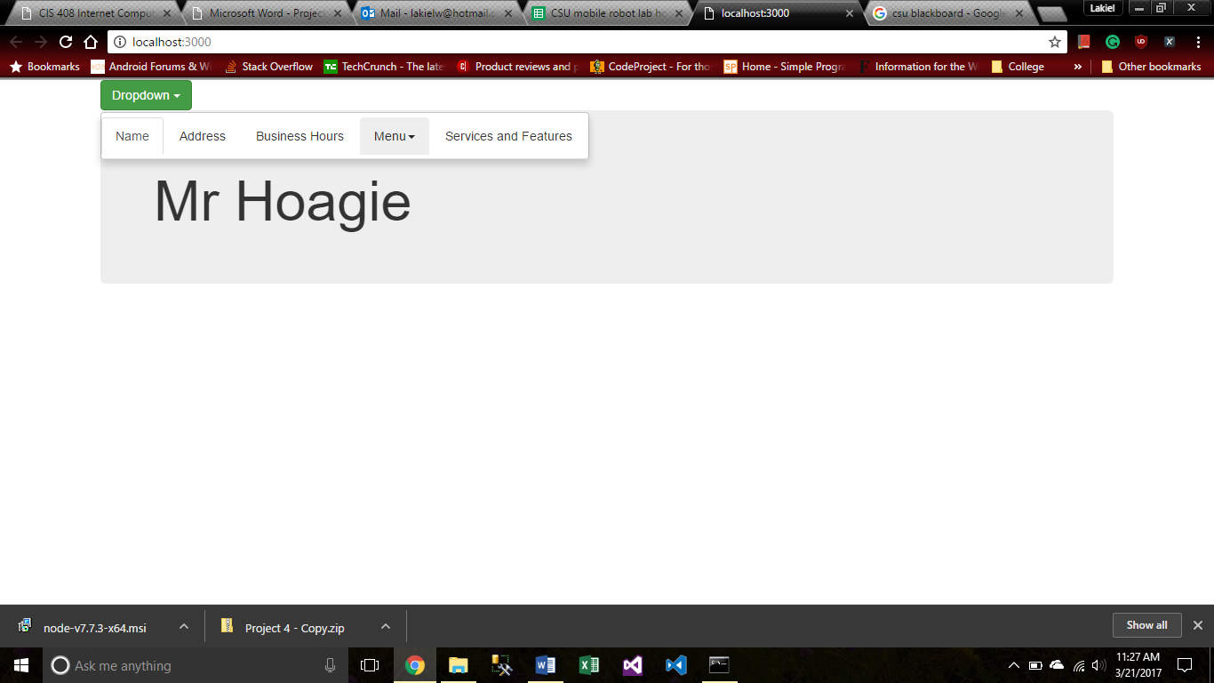

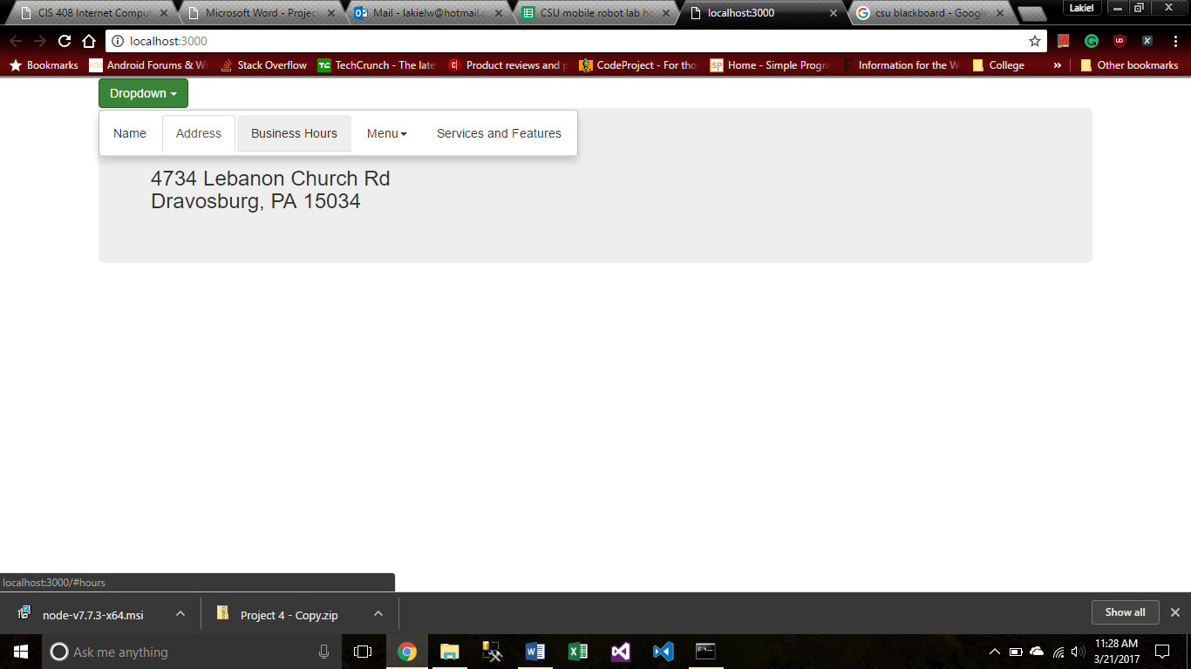

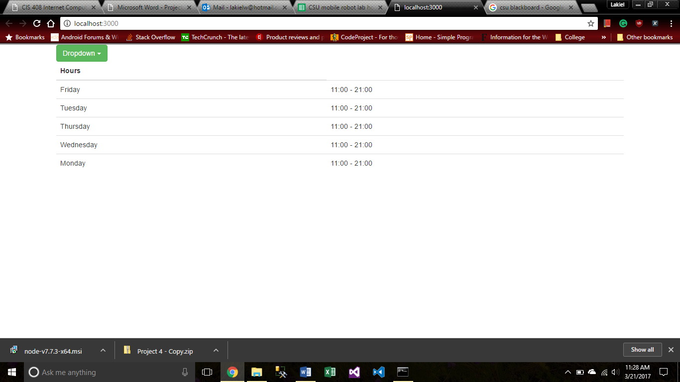

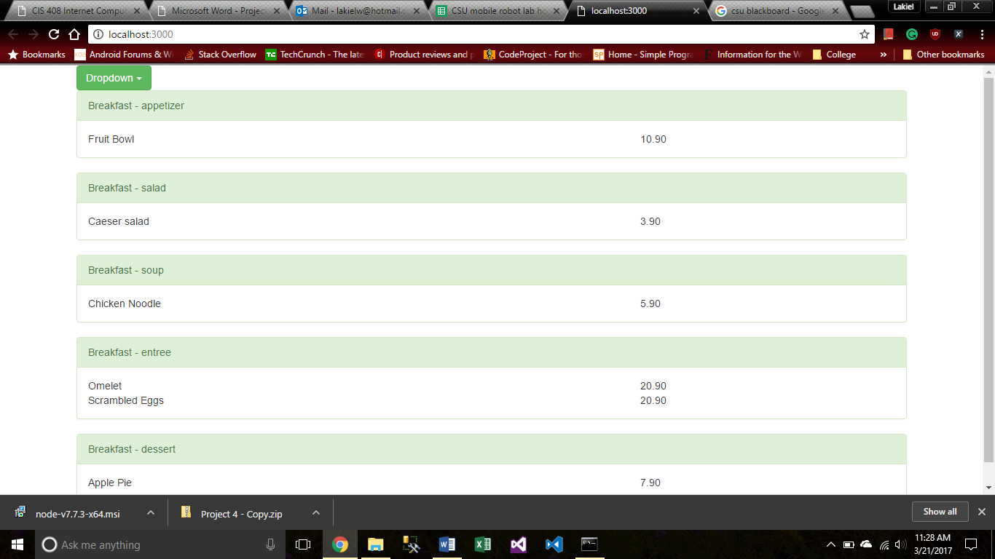

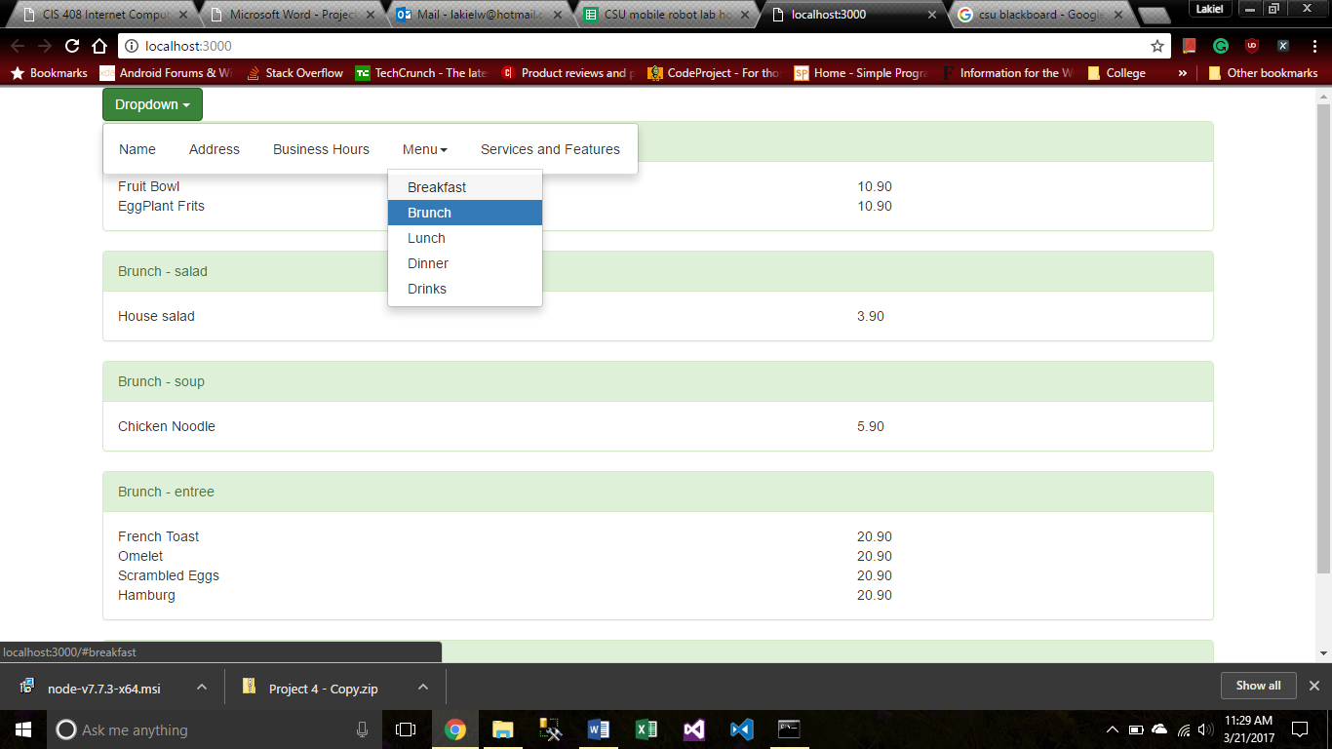

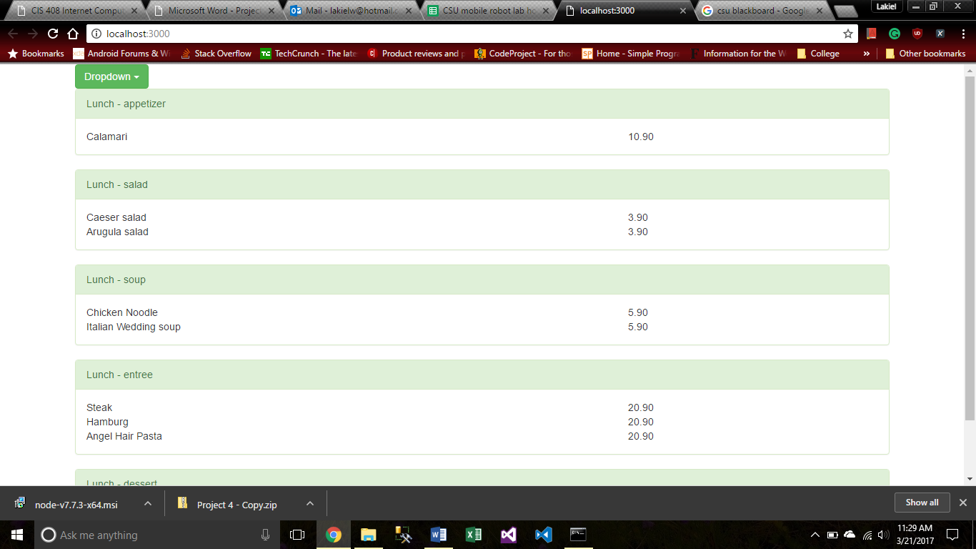

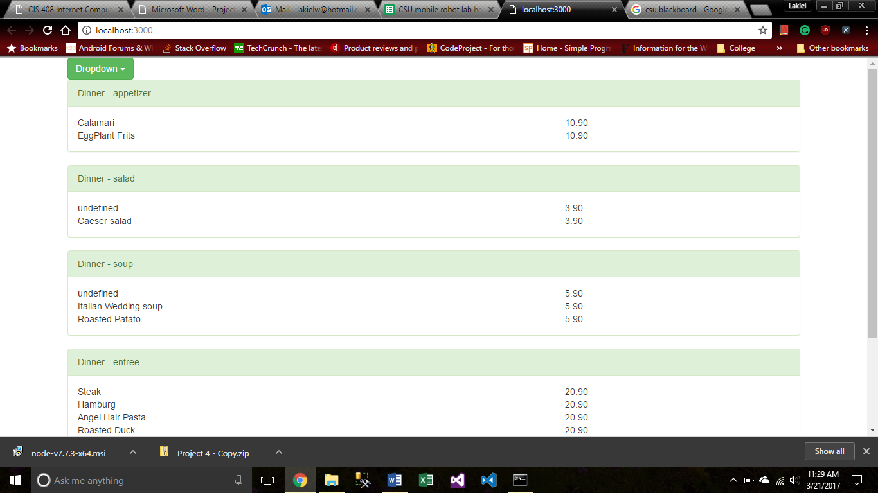

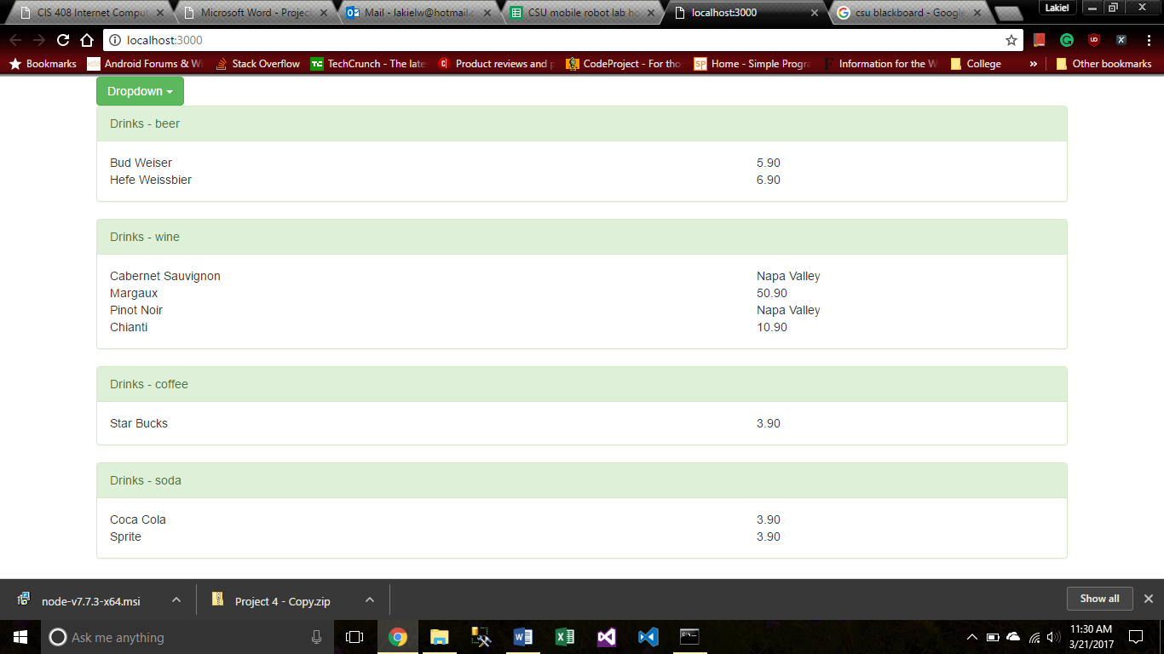

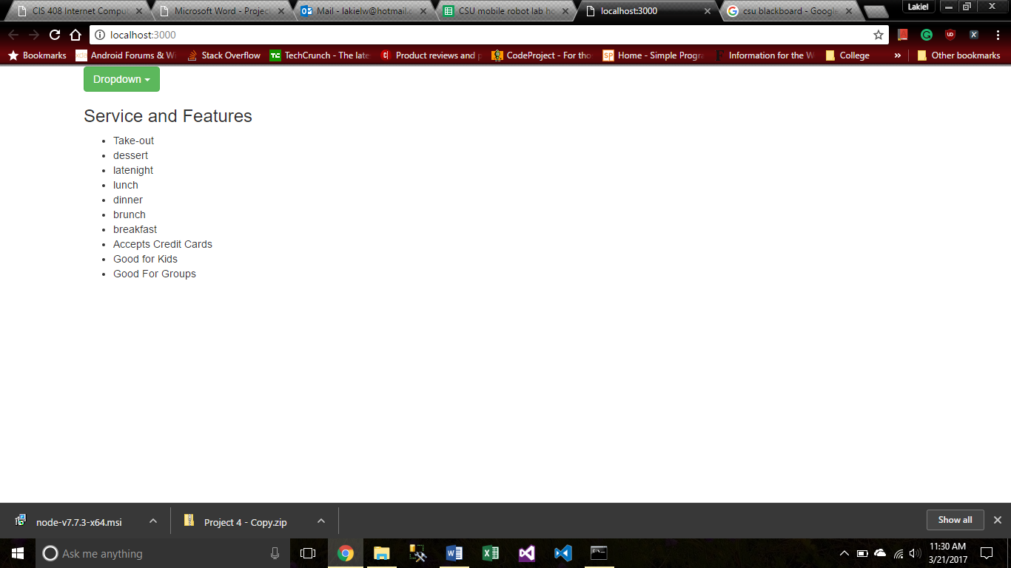

**Index.html**

<!DOCTYPE html>

<html>

<head>

    <meta http-equiv="Content-Type" content="text/html; charset=windows-1252">

    <link rel="stylesheet" type="text/css" href="bootstrap\dist\css\bootstrap.min.css" />

    <script src="jquery\dist\jquery.js"></script>

    <script src="bootstrap\dist\js\bootstrap.min.js"></script>

</head>

<body>

    <div class="container">

        <div class="dropdown">

            <button class="btn btn-success dropdown-toggle" type="button" data-toggle="dropdown">Dropdown

            <span class="caret"></span></button>

            <ul id="dropdown_menu" class="nav dropdown-menu nav-tabs">

                <li><a data-toggle="tab" href="#name">Name</a></li>

                <li><a data-toggle="tab" href="#address">Address</a></li>

                <li><a data-toggle="tab" href="#hours">Business Hours</a></li>

                <li id="dropdown_submenu" class="dropdown-submenu">

                    <a class="sub" id="menu" href="#">Menu<span class="caret"></span></a>

                    <ul id="menu_option" class="dropdown-menu"></ul>

                </li>

                <li><a data-toggle="tab" id="attributes" href="#service">Services and Features</a></li>

            </ul>

        </div>

        <div class="tab-content">

            <div id="name" class="tab-pane fade jumbotron">

                <h1 id=NameContent></h1>

            </div>

            <div id="address" class="tab-pane fade jumbotron">

                <h3 id=AddressContent></h3>

            </div>

            <div id="hours" class="tab-pane fade">

                <table id="HoursContent" class="table table-hover">

                    <thead>

                        <tr>

                            <th>Hours</th>

                        </tr>

                    </thead>

                    <tbody>

                    </tbody>

                </table>

            </div>

            <div id="breakfast" class="tab-pane fade">

                <div class="breakfast_content"></div>

            </div>

            <div id="brunch" class="tab-pane fade">

                <div class="brunch_content"></div>

            </div>

            <div id="lunch" class="tab-pane fade">

                <div class="lunch_content"></div>

            </div>

            <div id="dinner" class="tab-pane fade">

                <div class="dinner_content"></div>

            </div>

            <div id="drinks" class="tab-pane fade">

                <div class="drinks_content"></div>

            </div>

            <div id="service" class="tab-pane fade">

                <h3>Service and Features</h3>

                <ul id="service_content">

                </ul>

            </div>

        </div>

    </div>

    <script src="Parser.js"></script>

</body>

<script type="text/javascript">

    parseJson();

    parseXML();

    // SetEvents();

    $(document).ready(function () {

        $('.dropdown-submenu a.sub').on("click", function (e) {

            $(this).next('ul').toggle();

            e.stopPropagation();

            e.preventDefault();

        });

        $('#dropdown_menu li').on("click", function (e) {

            $("#dropdown_menu li").each(function (i, li) {

                if ($(li).hasClass("active"))

                    $(li).removeClass("active");

            });

            e.target.className = "active";

        });

    });

</script>

</html>

**Parser.js**

var jsonData;

const _CONTENT = "_content";

function InsertMenu(node, optionName, xmlData, category) {

    var divPanel = document.createElement("div");

    divPanel.setAttribute("class", "panel panel-success");

    var divPanelHeading = document.createElement("div");

    divPanelHeading.setAttribute("class", "panel-heading");

    divPanelHeading.appendChild(document.createTextNode(optionName + " - " + category));

    var divPanelBody = document.createElement("div");

    divPanelBody.setAttribute("class", "panel-body");

    var divRow = document.createElement("div");

    divRow.setAttribute("class", "row");

    divPanel.appendChild(divPanelHeading);

    path = "/menu/" + node.nodeName + "/" + category;

    var nodes = xmlData.evaluate(path, xmlData, null, XPathResult.ANY_TYPE, null);

    var result = nodes.iterateNext();

    while (result) {

        var divName = document.createElement("div");

        divName.setAttribute("class", "col-lg-8");

        divName.appendChild(document.createTextNode(result.childNodes[0].innerHTML));

        var divPrice = document.createElement("div");

        divPrice.setAttribute("class", "col-lg-4");

        divPrice.appendChild(document.createTextNode(result.childNodes[1].innerHTML));

        divRow.appendChild(divName);

        divRow.appendChild(divPrice);

        divPanelBody.appendChild(divRow);

        divPanel.appendChild(divPanelBody);

        var breakfast_content = document.getElementsByClassName(node.nodeName + _CONTENT);

        breakfast_content[0].appendChild(divPanel);

        result = nodes.iterateNext();

    }

}

function parseJson() {

    $.getJSON("LabJASON/OnebusinessDataFormat_yelp.json", function (data) {

        //sets name elements

        document.getElementById("NameContent").innerText = data["name"];

        //sets address elements

        document.getElementById("AddressContent").innerText = data["full_address"];

        //sets hour elements

        var hours = data["hours"];

        var table = document.getElementById("HoursContent");

        for (var key in hours) {

            if (hours.hasOwnProperty(key)) {

                var open = hours[key].open;

                var close = hours[key].close;

                var rowCount = table.rows.length;

                var row = table.insertRow(rowCount);

                var cell1 = row.insertCell(0);

                var cell2 = row.insertCell(1);

                cell1.innerHTML = key;

                cell2.innerHTML = open + " - " + close;

            }

        }

        var attributes = data["attributes"];

        var ul = document.getElementById("service_content");

        for (var x in attributes) {

            if (attributes.hasOwnProperty(x)) {

                var keyVal = attributes[x];

                if (typeof (keyVal) === 'object') {

                    for (var y in keyVal) {

                        if (keyVal.hasOwnProperty(y)) {

                            var innerKeyVal = keyVal[y];

                            if (innerKeyVal) {

                                var li = document.createElement("li");

                                li.appendChild(document.createTextNode(y));

                                ul.appendChild(li);

                            }

                        }

                    }

                } else if (typeof (keyVal) === 'boolean' && keyVal) {

                    var li = document.createElement("li");

                    li.appendChild(document.createTextNode(x));

                    ul.appendChild(li);

                }

            }

        }

    });

}

function parseXML() {

    var xmlData;

    var xhttp = new XMLHttpRequest();

    xhttp.overrideMimeType('text/xml')

    xhttp.onreadystatechange = function () {

        if (this.readyState == 4 && this.status == 200) {

            xmlData = xhttp.responseXML;

            var path = "/menu/*";

            if (xmlData.evaluate) {

                var nodes = xmlData.evaluate(path, xmlData, null, XPathResult.ANY_TYPE, null);

                var result = nodes.iterateNext();

                var menuOption_ul = document.getElementById("menu_option");

                while (result) {

                    //Creates submenu of menu items

                    var li = document.createElement("li");

                    var a = document.createElement("a");

                    var optionName = result.nodeName;

                    optionName = optionName.charAt(0).toUpperCase() + optionName.slice(1);

                    a.appendChild(document.createTextNode(optionName))

                    a.setAttribute("id", result.nodeName + _CONTENT);

                    a.setAttribute("tabindex", "-1");

                    a.setAttribute("data-toggle", "tab");

                    a.setAttribute("href", "#"+result.nodeName);

                    li.appendChild(a);

                    menuOption_ul.appendChild(li);

                    //Create panels from

                    InsertMenu(result, optionName, xmlData, "appetizer");

                    InsertMenu(result, optionName, xmlData, "salad");

                    InsertMenu(result, optionName, xmlData, "soup");

                    InsertMenu(result, optionName, xmlData, "entree");

                    InsertMenu(result, optionName, xmlData, "dessert");

                    InsertMenu(result, optionName, xmlData, "beer");

                    InsertMenu(result, optionName, xmlData, "wine");

                    InsertMenu(result, optionName, xmlData, "coffee");

                    InsertMenu(result, optionName, xmlData, "soda");

                    result = nodes.iterateNext();

                }

            }

        }

    };

    xhttp.open("GET", "LabJASON/restaurant_menu.xml", true);

    xhttp.send();

}